U.S. Radiocommunication Sector
Fact Sheet
Working Party: ITU-R WP 7D | Document No: USWP7D_25Sept-doc10-RA.[NGSO-RAS-RQZ]
Ref. Doc 7D/186, Annex 4 | Date: 7/14/2025
Document Title: Updates to Working document towards a preliminary draft new Report ITU-R RA.[NGSO-RAS-RQZ] - Mitigation techniques to improve data collection quality at Radioastronomy Observatory in the Radio Quiet Zones supporting the Square Kilometre Array (SKA) and the Atacama Large Millimeter/submillimeter Array (ALMA) in presence of non-GSO satellite systems
Author(s)/Contributors(s):  Frank Schinzel (NRAO)  Chris De Pree (NRAO) | fschinze@nrao.edu  cdepree@nrao.edu
Purpose/Objective: Review and merge documents and provide additional material toward this in-progress Report
Abstract: This document will provide a merged version with additional edits based on contributions provided by Telesat, USA, Canada, SKAO at the previous 7D meeting.

Radiocommunication Study Groups | 
Received: | Document 7D/XXX
 | XX September 2025
 | English only
United States of America
WORKING DOCUMENT TOWARDS A PRELIMINARY DRAFT
NEW REPORT ITU-R RA.[NGSO-RAS-RQZ]
Updates to Working document towards a preliminary draft new Report ITU-R RA.[NGSO-RAS-RQZ] - Mitigation techniques to improve data collection quality at Radioastronomy Observatory in the Radio Quiet Zones supporting the Square Kilometre Array (SKA) and the Atacama Large Millimeter/submillimeter Array (ALMA) in presence of non-GSO satellite systems

Introduction

This contribution provides a merged version updating the Working document towards a preliminary draft new report ITU-R RA.[NGSO-RAS-RQZ]. Specifically, combining inputs received by Telesat, USA, Canada, SKAO, and Korea. We also propose a new title for this report, implying this report to address studies according to resolves 5 of Resolution ITU-R 681: “Coexistence measures between non-GSO satellite systems and RAS stations in the Radio Quiet Zones supporting the Square Kilometre Array (SKA) and the Atacama Lage Millimeter/submillimeter Array (ALMA)”.
Edits are based on Annex 4 of Doc. 7D/186. Some editorial notes that the proposed edits addressed were removed for clarity, as well as colors from different contributions to provide a clean merged version of this document for further discussion and development. The United States also provides some additional text, not previously included in Annex 4, to further develop this document, highlighted through track changes. It is also proposed to restructure the document as presented in the attachment.

Attachment

ATTACHMENT
Radiocommunication Study Groups | 
Source: 7D/186, Annex 4 | Document XX
 | XX September 2025
 | English only
WORKING DOCUMENT TOWARDS A PRELIMINARY DRAFT
NEW REPORT ITU-R RA.[NGSO-RAS-RQZ]
Coexistence measures between non-GSO satellite systems and RAS stations in the Radio Quiet Zones supporting the Square Kilometre Array (SKA) and the Atacama Lage Millimeter/submillimeter Array (ALMA)
TABLE OF CONTENTS
1 Introduction 4
1.1 Properties of the ALMA protection and coordination zones 5
1.2 Properties of the South African astronomy advantage area 6
1.2.1 Geographic location and site shielding 6
1.2.2 Legislative and Regulatory control 7
1.2.3 Spectrum policy controls for broadcasting services 11
1.2.4 Maintenance of the RQZ 11
2 Techniques for mitigation of radio frequency interference (RFI) in RQZs 13
2.1 General Considerations 13
2.2 Considerations specific to the Square Kilometre Array (SKA), South Africa 13
2.3 Considerations specific to the Atacama Large Millimeter/Submillimeter Array (ALMA), Chile 13
3 Impact simulations 14
3.1 General simulation methodology 14
3.2 Simulations of coexistence measures 19
4 Summary 20
5 Related ITU-R Recommendations/Reports 20
6 Abbreviations/Glossary 20

1 Introduction
Radio telescopes operating in remote areas have benefited for many years from broad access to the entire electromagnetic spectrum. Given the highly sensitive nature of the receivers and weakness of the natural signals being detected, this has resulted in siting of RAS receivers by administrations in remote locations with extremely low population densities, as recommended by Recommendation ITU-R RA.769-2 and more generally outlined in the Radio Regulations (RR) Article 29. Additional protections from terrestrial receivers are provided through sovereign domestic regulations that in some cases establish special coordination or Radio Quiet Zones (RQZs). For details on such zones, refer to Report ITU-R RA.2259-1. However, as Recommendation ITU-R RA.769-2 recommends 2 and 3 describe, as administrations seek to afford protection to particular radio astronomical observations, all practicable steps should be taken, including particularly from high altitude platform stations, spacecraft and balloons and when planning global systems.
This Report focuses specifically on studies called for in Resolution 681 (WRC-23) resolves 5 “studies on new coexistence measures between non-GSO satellite systems and RAS stations in the RQZs specified in considering k)”, which are:
- The Square Kilometre Array Observatory (SKAO) in South Africa.
- The Atacama Large Millimeter/submillimeter Array (ALMA) in Chile.

The following subsections provide details on the two specific RQZs of concern, with relevant characteristics for establishing measures to mitigate interference from nGSO satellite systems, which in the following text are referred to as coexistence measures. Section 2 provides a summary of relevant techniques that can be used to mitigate impacts of nGSO satellite systems on RAS systems in the two RQZs. Section 3 provides a description of methods to evaluate impacts of coexistence measures. The Annexes provide examples of national experiences from applying coexistence measures under domestic rules.

1.1 Properties of the ALMA protection and coordination zones
The Atacama Large Millimeter/submillimeter Array (ALMA), an international astronomy facility, is a partnership of the European Organisation for Astronomical Research in the Southern Hemisphere (ESO), the U.S. National Science Foundation and the National Institutes of Natural Sciences (NINS) of Japan in cooperation with the Republic of Chile. ALMA is funded by ESO on behalf of its Member States, by NSF in cooperation with the National Research Council of Canada (NRC) and the Ministry of Science and Technology (MOST) in Taiwan and by NINS in cooperation with the Academia Sinica (AS) in Taiwan and the Korea Astronomy and Space Science Institute (KASI). ALMA construction and operations are led by ESO on behalf of its Member States; by the NSF National Radio Astronomy Observatory (NRAO), managed by Associated Universities, Inc. (AUI), on behalf of North America; and the National Astronomical Observatory of Japan (NAOJ) on behalf of East Asia.
The ALMA radio telescope is situated in an uninhabited region of northern Chile at an elevation of 5 000 m. To protect the operations of the ALMA telescope, the ALMA partners must abide by the regulations of the Chilean national telecommunications authority SUBTEL and the identical Resolution 1055 issued to AUI for North America and Resolution 1056 to the European Southern Observatory (ESO) in August 2004. The English-language translation of Resolution 1055 is presented in Attachment 1 to Annex 3 in Report ITU-R RA.2259-1.
In May 2003, AUI and ESO signed the acquisition from the Chilean Ministry of National Assets of land for the ALMA Operations Support Facility. In November 2003, the Chilean Ministry of National Assets provided a 50-year land concession for the construction and operation of ALMA on the Chajnator Altiplano, an area known as “the ALMA Concession.” In 2013, the land was designated for exclusive use of scientific activities and the National Commission for Research in Science and Technology (CONICYT) created the Parque Astronomico de Atacama (PAA) for managing the land concession. The PAA defined two zones centered on 23º 01’ S by 67º 45’ W:
i) Protection Zone: with a radius of 30 km, within Chilean national territory. Third-party transmitters operating within certain frequency bands may not be stationed within this zone.
ii) Coordination Zone: with a radius of 120 km, within Chilean national territory. Operators wishing to station certain kinds of transmitters within this zone are subject to a process whereby the opinion of the petitioners, ESO and AUI, are sought regarding requests that could interfere or affect the operation of the radio telescope.
Figure 1.1-1
ALMA protection and coordination zones, as defined by the SubTel Exempt Resolutions,
with a radius of 30 and 120 km respectively within the Chilean territory. The black line
shows the border between Chile, Bolivia, and Argentina
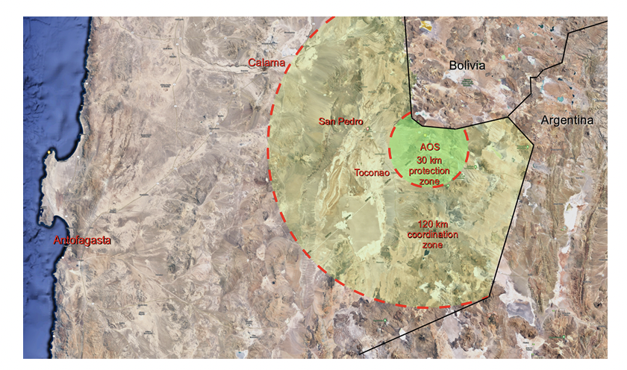

1.2 Properties of the South African astronomy advantage area
To protect radio astronomy observations from detrimental radio frequency interference in South Africa, a national legislative and regulatory framework has been developed for the specific purpose of establishing radio quiet zones. South Africa has adopted a multi-pronged approach to achieve a radio quiet zone (RQZ), which includes:
i) Selection of a site with characteristics like topographical shielding;
ii) Legislative and regulatory controls, which includes limitation and prohibition of sources of detrimental radio-frequency interference (RFI), Electromagnetic Interference (EMI);
iii) Policy controls, which result in improved spectrum efficiency in and around the RQZ; and
iv) Maintenance of RQZ.

1.2.1 Geographic location and site shielding
The site is located in the Karoo area of the Northern Cape Province. Its location takes advantage of two factors that influence the existing radio-frequency environment as measured at the site:
i) the area is sparsely populated, with an average population density of less than one person per square kilometre outside of the small communities; and
ii) The prevalence of hills provides natural topographical shielding against distant sources of RFI as illustrated in Fig. 1.2.1-1.
FIGURE 1.2.1-1
Natural shielding of the MeerKAT/SKA telescope shown through a 300 MHz
pathloss profile from a nearby Farm House
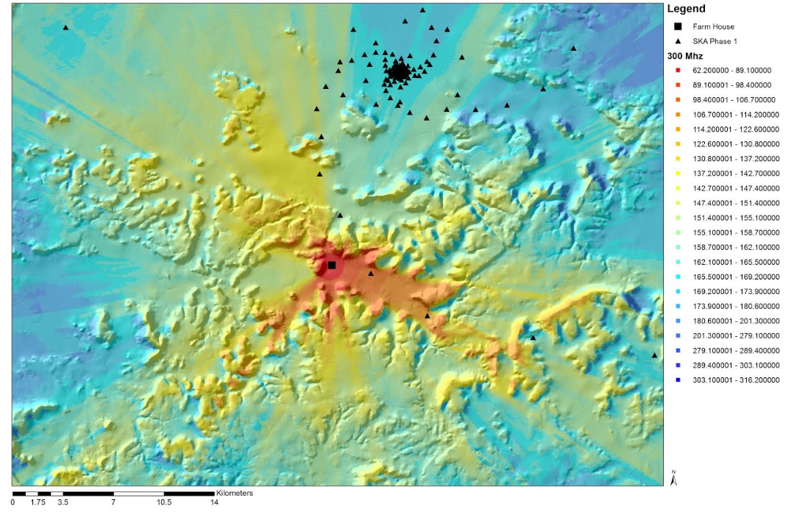

1.2.2 Legislative and Regulatory control
On 17 June 2008, the Parliament of the Republic of South Africa (RSA) enacted the Astronomy Geographic Advantage Act (AGA Act) into law to provide for the preservation and protection of areas within the Republic that are uniquely suited for radio astronomy.

1.2.2.1 Declaration of the Karoo core and central astronomy advantage areas
After the enforcement of the AGA Act, the following Astronomy Advantage Areas were declared for the purposes of radio astronomy and related scientific endeavors, which are also shown in Fig. 31. The protected area is bounded by the meridians of longitudes at 18 ̊ 48′ 54.65″ E and 23 ̊ 25′ 40.44″ E and latitudes of -28 ̊ 46′ 44.4″ S and 32 ̊ 22′ 10.56″ S:
i) The Karoo Core Astronomy Advantage Area (KCoreAAA), which covers an area of about 13 406 hectares; and the
ii) Karoo Central Astronomy Advantage Areas (KCAAAs 1, 2, and 3), of which the larger one covers an area of about 10 705 284 hectares.
FIGURE 1.2.2.1-1
Declared Karoo Core and Karoo Central Astronomy Advantage Areas
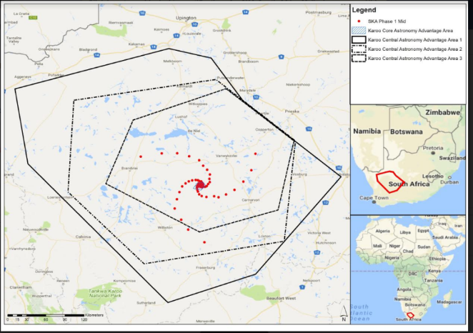
Regulations were published for both the KCoreAAA and KCAAAs, which includes varying levels of prohibitions and restrictions to protect the radio astronomy. The regulations are summarised as follows:
i) KCoreAAA Regulations – all the radio transmissions within the regulated radio-frequency spectrum are prohibited, unless for the purposes of radio astronomy;
ii) KCAAA Regulations – provides for an impact assessment and permitting framework that enables radiocommunication so long as the assessed impact complies with relevant conditions and restrictions.
The AGA Act makes provision for the declaration of Coordinated Astronomy Advantage Areas. Most of the area that lies outside the KCAAA 1 within the Northern Cape Province is designated to be declared as the Karoo Coordinated Astronomy Advantage Area to limit the impact of high-powered transmitters on the KCoreAAA and KCAAAs. The Regulations governing restrictions and prohibition of radio transmissions within the Karoo Coordinated Astronomy Advantage Area is still being developed

1.2.2.2 Prohibition of spectrum usage
Unless otherwise authorised in terms of relevant regulatory provisions, spectrum usage as prescribed for the Karoo Core and Central Astronomy Advantage Areas in Table 1.2.2.2-1 is prohibited. A list of frequency bands that will be exempted from the prohibition in Table 1.2.2.2-1 for delivery of radiocommunication services to communities in the Karoo is still being developed. The basis of identifying exempted frequency bands is one of spectrum efficiency – to deliver essential services within the available spectrum resource. Authorisation to operate radiocommunication equipment within the declared KCAAAs is subject to obtaining an appropriate permit.
TABLE 1.2.2.2-1
Protected Area and prohibited frequency range
Declared area | Prohibited band | Coordinates of the points defining the polygons
KCoreAAA | 9 kHz to 3 000 GHz | ~8 km around central point  located at approximately 30.71° S, 21.44° E
KCAAA 1 | 100 MHz to 2 170 MHz | - A1 (29.3500° S, 18.8100° E)  - B1 (28.7800° S, 20.9900° E)  - C1 (28.9100° S, 21.6000° E)  - D1 (29.5200° S, 22.0500° E)  - E1 (30.5900° S, 23.4300° E)  - F1 (31.9600° S, 22.2200° E)  - G1 (32.3700° S, 20.9800° E)  - H1 (30.4100° S, 19.0000° E)
KCAAA 2 | 100 MHz to 6 GHz | - A2 (29.5100° S, 19.6600° E)  - B2 (29.2200° S, 21.6600° E)  - C2 (30.0800° S, 22.7700° E)  - D2 (31.5100° S, 22.6300° E)  - E2 (31.8200° S, 20.6500° E)  - F2 (30.8100° S, 19.5700° E)
KCAAA 3 | 100 MHz to 25.5 GHz | - A3 (29.7900° S, 20.4900° E)  - B3 (29.3400° S, 21.8100° E)  - C3 (30.0800° S, 22.7600° E)  - D3 (31.0600° S, 22.5400° E)  - E3 (31.3800° S, 21.4200° E)  - F3 (30.6800° S, 20.1000° E)

1.2.2.3 Management of the Karoo Core and Central Astronomy Advantage Areas
An Astronomy Management Authority (AMA) has been assigned by the Minister for Science and Technology with the responsibility to administer the processes and procedures to: implement the protection requirements; to conduct compliance assessment and to issue permits with appropriate radio transmission specifications.

1.2.2.4 Conditions for spectrum use within the KCAAAs
Any radio-frequency spectrum usage and radiocommunication transmissions shall comply with conditions prescribed in the regulations. Penalties are imposed in cases where these conditions are transgressed as stated below:
a) the received power level shall not exceed a saturation level of (minus) −100 dBm at any radio astronomy station within the MeerKAT/SKA protection corridors or within 20 km of the SKA Virtual Center. The SKA Virtual Centre is a compliance assessment point for the applicable protection levels for radio astronomy as defined under (b) and it is located at the geographic coordinates 30.71292 S and 21.44380 E; and
b) the protection levels to be applied in astronomy advantage areas, and used as a basis for all impact assessments, is illustrated in Fig. 2.2.4-1. Radio transmissions shall not exceed the protection levels applied at the SKA Virtual Centre. The protection levels are derived using methodologies described in Recommendation ITU-R RA.769-2, and are designated as the South African Radio Astronomy Service protection levels (SARAS protection levels) and it is described by the following equations in the regulation published in terms of the AGA Act:
SARAS (dBm/Hz) = −17.2708 log (f) – 192.0714 for f < 2 GHz, the values of (f) in MHz
SARAS (dBm/Hz) = −0.065676 log (f) – 248.8661 for f ≥ 2 GHz, the values of (f) in MHz
FIGURE 1.2.2.4-1
South African radio astronomy service protection levels
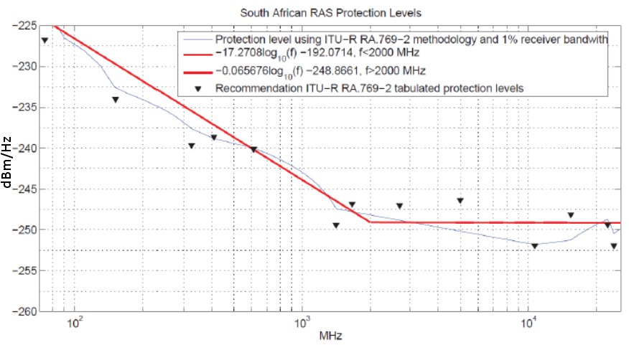

1.2.2.5 Restriction of spectrum use

1.2.2.5.1 Licensed spectrum use
Licensed transmitters that operate in exempted frequency bands (see § 1.2.2.2) are restricted, by way of a permitting process, to prevent detrimental impact from RFI at pre-defined locations occupied by MeerKAT/SKA receptors. Radio transmission on the frequency band not exempted is prohibited. The special section in the South African Table of Frequency Allocation also prescribes that all licensed spectrum users in the declared areas are to be subjected to authorization in a procedure prescribed under the AGA Act.

1.2.2.5.2 Unlicensed spectrum use
The Independent Communication Authority of South Africa (ICASA) has prescribed a list of radio equipment (short-range devices) and their technical standards and specifications for which spectrum licenses have been exempted. Such equipment shall not be operated within 50 km of the SKA Virtual Centre unless a permit has been issued by the astronomy management authority.
Outside the 50 km radius, certain unlicensed transmitters emitting e.i.r.p. of 250 mW or less will be exempted from the requirements of obtaining a permit in terms of the AGA Act for operation within license exempted spectrum, unless such transmission interferes with the radio telescope.

1.2.2.5.3 Unintentional radio emissions
The location and configuration of the MeerKAT and the SKA telescope receiver was identified after consideration of existing electromagnetic interference sources. New electrical equipment and electrical infrastructure with power rating of greater than 100 kVA and within 30 km from the nearest SKA infrastructure requires a permit to be issued by the management authority after assessing the interference level and determining the separation distance required to minimize interference. For electricity generation by means of wind turbines, the distance is 50 km. If a permit to operate is granted, it will include all the conditions that the operator must comply with relating to the electrical infrastructure and equipment. The avoidance of interference by the electrical equipment shall be achieved by separating it from the nearest SKA infrastructure by a separation distance where RFI level due to electromagnetic emissions comply with the SARAS protection level.

1.2.3 Spectrum policy controls for broadcasting services
To protect the MeerKAT and the SKA radio telescopes, all terrestrial television broadcast transmissions in the KCAAAs have been prohibited. Television broadcast transmissions may only be via direct-to-home satellite transmissions in the frequency band 10.7 to 12.5 GHz.

1.2.4 Maintenance of the RQZ
The RQZ in the KCAAA is maintained by routine measurements of the radio frequency environment using four fixed spectrum monitoring installations near the four closest towns and two fixed spectrum monitoring installations at the MeerKAT and SKA core. Provision is made to have a spectrum monitoring equipment on each spiral arm. Fixed spectrum monitoring equipment is strategically placed at nine geographic locations around and within an array of SKA Phase 1 telescope receivers. The Astronomy Management Authority (AMA) and ICASA entered into a Memorandum of Agreement to provide the framework and mechanism for cooperation between the two parties in cases of identified interference and compliance enforcement.
1.2.5 RAS stations located within the RQZ
The following RAS stations were filled by the South African administration to the ITU-R and are registered in the ITU-R Master International Frequency Register (MIFR),
TABLE 1.2.5-1
List of RAS stations in the South African RQZ
ntc_id | stn_name | lat_dec | long_dec
118505135 | MEERKAT | ‒30.7128 | 21.4436
121505199 | SKA CORE | ‒30.7128 | 21.4436
121505200 | SKA107 | ‒30.7225 | 21.3975
121505201 | SKA113 | ‒30.7364 | 21.3917
121505202 | SKA118 | ‒30.7522 | 21.3947
121505203 | SKA119 | ‒30.7786 | 21.3972
121505204 | SKA121 | ‒30.8019 | 21.4128
121505206 | SKA125 | ‒30.8653 | 21.4589
121505207 | SKA123 | ‒30.8417 | 21.4236
121505208 | SKA126 | ‒30.8797 | 21.5086
121505209 | SKA128 | ‒30.8692 | 21.6356
121505210 | SKA127 | ‒30.8836 | 21.6972
121505211 | SKA124 | ‒30.8444 | 21.8044
121505212 | SKA120 | ‒30.7597 | 21.8875
121505213 | SKA011 | ‒30.5017 | 22.1622
121505214 | SKA004 | ‒30.2808 | 22.2219
121505215 | SKA117 | ‒30.7367 | 21.4728
121505216 | SKA115 | ‒30.7372 | 21.4939
121505217 | SKA110 | ‒30.7347 | 21.5111
121505218 | SKA105 | ‒30.7239 | 21.5322
121505219 | SKA027 | ‒30.695 | 21.5511
121505220 | SKA022 | ‒30.6697 | 21.5739
121505221 | SKA014 | ‒30.6222 | 21.5683
121505222 | SKA021 | ‒30.6589 | 22.0467
121505223 | SKA013 | ‒30.5608 | 21.5767
121505224 | SKA012 | ‒30.4953 | 21.5369
121505225 | SKA010 | ‒30.4372 | 21.4811
121505226 | SKA009 | ‒30.3611 | 21.4236
121505227 | SKA007 | ‒30.3031 | 21.2831
121505228 | SKA006 | ‒30.2606 | 21.1122
121505229 | SKA005 | ‒30.2622 | 20.8933
121505230 | SKA023 | ‒30.6744 | 21.4608
121505231 | SKA020 | ‒30.6594 | 21.4517
121505232 | SKA018 | ‒30.6539 | 21.4258
121505233 | SKA017 | ‒30.6431 | 21.4064
121505234 | SKA016 | ‒30.6436 | 21.3258
121505235 | SKA015 | ‒30.6386 | 21.3742
121505236 | SKA019 | ‒30.6589 | 21.2769
121505237 | SKA025 | ‒30.6867 | 21.2308
121505238 | SKA112 | ‒30.7289 | 21.1839
121505239 | SKA122 | ‒30.8097 | 21.1447
121505240 | SKA129 | ‒30.9106 | 21.1089
121505241 | SKA130 | ‒31.0419 | 21.0772
121505242 | SKA131 | ‒31.2014 | 21.1694
121505243 | SKA132 | ‒31.3408 | 21.2678
121505244 | SKA133 | ‒31.5197 | 21.4989
121505245 | SKA008 | ‒30.3086 | 20.5975
122505043 | SKA116 | ‒30.7419 | 21.4603
122505062 | SKA114 | ‒30.7397 | 21.4525
122505063 | SKA111 | ‒30.7342 | 21.4425
122505064 | SKA109 | ‒30.7294 | 21.4378
122505065 | SKA108 | ‒30.7253 | 21.4339
122505066 | SKA070 | ‒30.7131 | 21.4583
122505067 | SKA060 | ‒30.7125 | 21.4053
122505068 | SKA037 | ‒30.7086 | 21.4622
122505069 | SKA034 | ‒30.7061 | 21.4136
122505070 | SKA032 | ‒30.7028 | 21.4647
122505071 | SKA030 | ‒30.7022 | 21.4392
122505072 | SKA029 | ‒30.7014 | 21.4344
122505073 | SKA028 | ‒30.7008 | 21.4303
122505074 | SKA026 | ‒30.6922 | 21.4639
122505075 | SKA024 | ‒30.6900 | 21.4600

2 Techniques for mitigation of radio frequency interference (RFI) in RQZs

2.1 General Considerations
Report ITU-R RA.2126 provides a summary of techniques that could be considered for mitigation of interference with radio astronomical observations. In the context of non-GSO satellite systems, the particular method of boresight avoidance is described in detail in Report ITU-R RA.2126, with a summary highlighting a national experience of this method in Annex 1. While not all satellite systems are capable to perform boresight avoidance, other approaches should be considered to improve data collection of astronomical data. Such approaches might include:
Temporal avoidance and frequency hopping
Reduction of transmit power levels
Null Steering
While different methods have advantages and disadvantages, most technical approaches require a real-time knowledge of operational parameters of both the radio astronomical and satellite systems.
In addition to technical considerations, ground-based infrastructure served by satellite systems are under the purview of individual administrations, which can make rules to encourage coordination between RAS and satellite systems for placement and operation of e.g. user terminals or gateway stations to minimize impacts for both RAS and satellite systems.

2.2 Considerations specific to the Square Kilometre Array (SKA), South Africa

2.3 Considerations specific to the Atacama Large Millimeter/Submillimeter Array (ALMA), Chile
Possible approaches for voluntary measures that may ensure coexistence between non-GSO satellite systems operating in frequency bands allocated to the FSS and/or MSS on a primary or a secondary basis and the ALMA RAS facility operating in bands where RAS has no allocation that could be employed are described in this section.

2.3.1 Approaches to improve data collection at ALMA in presence of non-GSO satellite systems
Given the operating frequencies of ALMA, satellites operating at altitudes of 500 – 1200 km, would be able to form small spot beams covering areas of [xxx-xxx km]. Approaches for coexistence between satellite operators and the observatory would allow for effective temporary boresight avoidance, while a particular observing band is in use. This approach would allow for the operation of earth stations in closer vicinity of the facility. With sufficient separation between RAS facilities and earth stations, power levels from satellite systems could be minimized to be below thresholds specified in Recommendation ITU-R RA.769-1. Deployment of terminals and gateways are a matter of domestic regulation and are already covered under the protection zones specified and governed by licensing requirements through SUBTEL. However, in case if no earth stations were permitted to operate within the 30 km or 120 km-wide protection and coordination zones, the boresight avoidance might not be needed, or only needed for limited cases where low satellite elevation angles could encounter the telescope boresight.

3 Impact simulations

3.1 General simulation methodology
This section discusses the general methodology to simulate the impact of different coexistence methods.

3.1.1 Non-GSO systems description
The non-GSO system shall be described using the following parameters based on ITU-R Recommendation ITU-R SM.1413-4:

TABLE 3.1.1-1
Non-GSO FSS system orbital parameters
Parameter | System A | System B | System C
Orbit height (km) | 590, 610, 630 | 525, 530, 545 | 1200
Inclination angle (deg) | 33, 42, 51.9 | 53, 43, 33 | 87.9
Right Ascension Of The Ascending Node (RAAN) boundaries | Equally spaced  0-359 deg | Equally spaced  0-359 deg | Equally spaced  0-179 deg
Number of planes | 28, 36, 34 | 28, 28, (24, 4) | 18
Satellites per plane | 28, 36, 34 | 120, 120, (28,27) | 40
Frequency (GHz) | 42-42.5 / 74-76 | 10.7-10.95 / 74-76 | 10.7-10.95
Channel bandwidth (MHz) | 100 | 250 / 1250 | 250
Number of beams per channel | 16 | 32 / 200 | 32
Antenna pattern
Antenna characteristics defined for pattern
Minimum elevation angle (degrees) | 20 | 25 / 15 | 30
Satellite Selection strategy | Random
Out of band emission mask | ITU-R SM.1541-6
Maximum number of non-GSO satellites operating co-frequency (Nco) | 16 / 32 | 1 / 32 | 1
Pointing strategy for non-GSO satellites in visibility and not pointing towards the latitude of interest | Random
Power flux density to the ground dBW/m²/MHz | -125 to -104 | -122 / -106 | -121
Power flux density control mode

As orbits in this report are assumed to be circular, the orbit height parameter is setting both Apogee Altitude (RDD ref: S098) and Perigee Altitude (RDD ref: S099). This also means that Eccentricity (RDD ref: S101) is zero. The RAAN boundaries and number of planes allow to calculate RAAN (RDD ref: S097) for each orbital plane. The Perigee Argument (RDD ref: S100) for circular orbits just defines the starting anomaly (orbital coordinate of each satellite)

3.1.2 Satellite position propagation
Studies in this report uses the Simplified Perturbations Model 4 (SGP4) as all orbits’ heights considered are below 5 877.5 km. The model is further simplified by assuming absence of drag.

3.1.3 Satellite selection and pointing
Selection of the satellite to serve the area with RAS station and pointing strategy might strongly impact the results of any studies.
Satellite selection used for studies by default is random, meaning that the satellite (or satellites) to serve the geographical area containing RAS station is selected on a pure random basis. Other alternatives could be based on “the highest elevation angle”, “the shortest slant range” and the “longest hold time”. It is important that throughout the assessment of coexistence measure impact the same satellite selection strategy is preserved as the used strategy itself might change the outcome.
Selection is also subject to “maximum number of non-GSO satellites operating co-frequency” also called “Nco”. This parameter defines maximum number of satellites to serve the geographical area containing RAS station (thus pointing to RAS station) and all other satellites in visibility but not part of the “Nco” satellites point towards a random point on Earth’s surface.
Since Nco already defines the maximum number of satellites that could point to RAS station’s location, all other satellites should point away from the RAS station. The exact minimum true angular separation distance between the direction towards RAS station and satellite pointing for non-Nco satellites might be dependent on the system, but the first approximation could be to ensure that such separation is greater than ‒3 dB beamwidth.
The pointings of non-Nco satellites is also subject to the minimum elevation angle of the respective satellite system to ensure that such pointings represent the satellite system’s behaviour. This would effectively limit the angle $β$ / “beta” (RDD ref: S368, see Recommendation ITU-R SM.1413-4 for details). Approximating Earth as a sphere, the maximum beta angle will be defined by the following equation:
$β_{max}=⁡arcsin(\frac{R_{Earth}*sin(90°+e_{min})}{R_{Earth}+alt})$,
where:
$R_{Earth}$: Earth radius, equals 6 378.1 km as per IAU 2015 Resolution B3
$e_{min}$: satellite system’s minimum operational elevation angle. If $e_{min}$ equals 0, this would be the edge case showing maximum possible angle $β$ / “beta” for visible satellites
$alt$: current satellite’s altitude or height. For circular orbits this would be a constant value
$β_{max}$: the maximum operational angle $β$ / “beta.
Finally, while pointings of non-Nco satellites are random, the exact distribution used for random generator might also alter the results. Since pointing is defined by angles α and $β$ (RDD ref: S121 and RDD ref: 368 respectively), one possible solution would be to use uniform distribution for both of them. However, this would lead to pointings effectively clustering around nadir point as shown in Fig. 3.1.3-1.
Figure 3.1.3-1
Pointing distribution with uniform distribution applied to both α and $β$
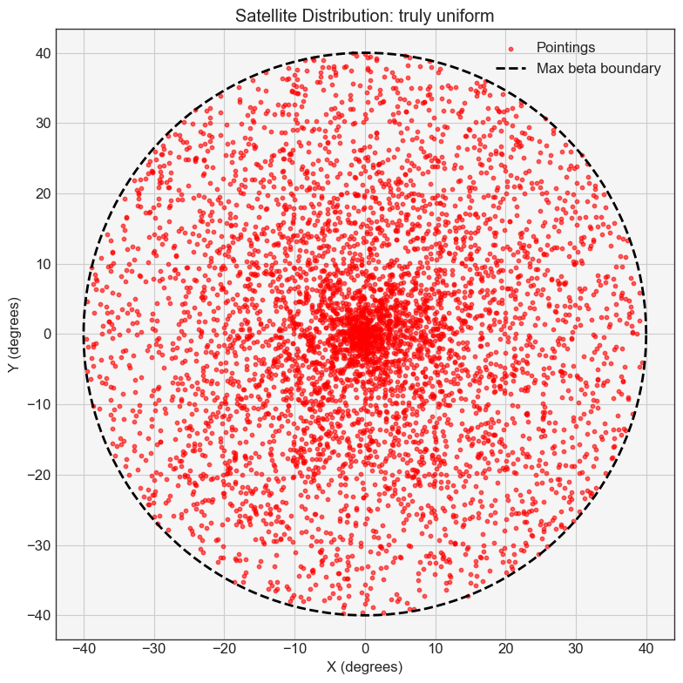
One possible way to enhance would be to apply correction to the uniform distribution of $β$ angle as following:
$β=arccos⁡(1-u*(1-cos⁡(β_{max})))$,
where:
$β_{max}$: the maximum operational angle $β$ / “beta
$u$: random values uniformly distributed between 0 and 1, so it could be the original uniform distribution divided by $β_{max}$
$β$: new values for angle $β$.
This correction, aiming at ensuring having similar probability for all directions in a cone, would result in the distribution presented in Fig. 3.1.3-2.
Figure 3.1.3-2
Pointing distribution with uniform distribution applied to α and amended distribution applied to $β$
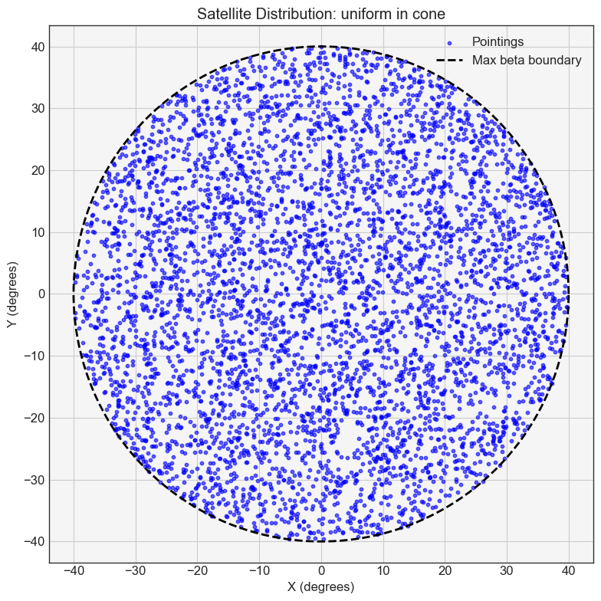
However, it should be noted that since the area of service cone lands on a sphere, there is further distortion that is not taken into account in Figures 2 and 3. While it’s hard to determine the best distribution to represent the satellite system behaviour, it can be seen that for comparison purposes it might be important that studies contain such information.

3.1.4 Radio wave propagation
The easiest way to determine the path loss is to apply the free space path loss as per Recommendation ITU-R P.525-5. However, this could be valid only as a rough approximation due to atmospheric influence on propagation. For studies with frequencies below 100 GHz Recommendation ITU-R P.619-5 might be considered to be used, while for studies with frequencies above 100 GHz a combination Recommendation ITU-R P.525-5 in conjunction with Recommendation ITU-R P.676-13 might be considered.

3.1.5 RAS station pointings and number of trials
As the RAS station can point in any direction in azimuth and elevation, it is necessary to define a pointing map in the sky. Recommendation ITU-R S.1586-1 shall be used to generate random pointings in the sky in az-el. Celestial coordinates (right ascension and declination) can be used as an alternative reference frame using the same cell distribution method described in the aforementioned recommendation.
As studies considering non-GSO are inherently statistical, the scenarios shall be simulated in a number of iterations. The number of iterations necessary depends on the parameters of the non-GSO system, therefore the convergence of the result (per sky cell) should be assessed to ensure the necessary iterations were simulated.
Each iteration can alter the starting time of the simulation (which will affect the distribution of the non-GSO system in the local sky) and the pointing of the radio telescope within each sky cell.

3.1.6 Metrics used for comparison of results
A commonly used metrics to discuss simulations related to radio astronomy is cumulative distribution function (CDF). However, for more in-depth visual analysis a complementary cumulative distribution function (CCDF) might be more useful as it provides more details for rare events. Examples of simulation results in CDF and CCDF are shown in Fig. 3.1.6.
Figure 3.1.6-1
Example of study results in CDF (a) and CCDF (b) forms
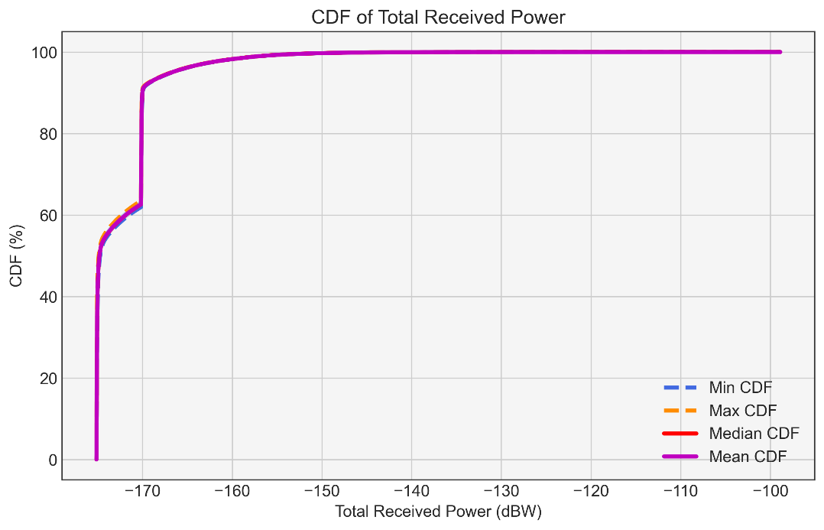
a)
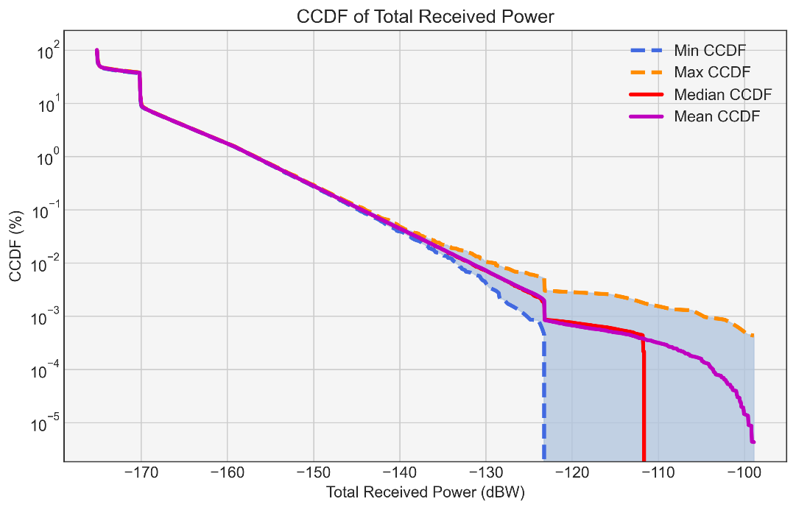
b)

3.2 Simulations of coexistence measures
[Editor’s Note: To be filled with measures and their respective impact assessments.]

4 Summary

5 Related ITU-R Recommendations/Reports
Recommendation ITU-R RA.769 ‒ Protection criteria used for radio astronomical measurements
Recommendation ITU-R RA.1513 ‒ Levels of data loss to radio astronomy observations and percentage-of-time criteria resulting from degradation by interference for frequency bands allocated to the radio astronomy service on a primary basis
Recommendation ITU-R SM.1413 ‒ Radiocommunication Data Dictionary for notification and coordination purposes
Recommendation ITU-R S.1586 ‒ Calculation of unwanted emission levels produced by a non-geostationary fixed-satellite service system at radio astronomy sites
Recommendation ITU-R P.525 ‒ Calculation of free-space attenuation
Recommendation ITU-R P.619 ‒ Propagation data required for the evaluation of interference between stations in space and those on the surface of the Earth
Report ITU-R RA.2126 ‒ Techniques for mitigation of radio frequency interference in radio astronomy
Report ITU-R RA.2259 ‒ Characteristics of radio quiet zones

6 Abbreviations/Glossary

Annex 1
Example of operational co-existence measures – The National Radio Quiet Zone in the United States and boresight avoidance technique implemented
by a Low Earth Orbit (LEO) satellite system
The U.S. National Radio Astronomy Observatory (NRAO) and a LEO satellite operator have been engaged in coordinated testing efforts since Fall 2021, including conducting experiments on different interference avoidance schemes for the Karl G. Jansky Very Large Array (VLA) in New Mexico, and the Green Bank Telescope (GBT) inside the U.S. National Radio Quiet Zone in West Virginia. The satellite system used is capable of avoiding direct illumination of telescope sites with their adaptive tasking to place downlink beams far away. Nevertheless, even satellites operating in this mode can potentially present strong signals into the telescope’s receiver system if they pass close to the telescope’s main beam at the boresight. For additional protection, satellites can either momentarily redirect or completely disable their downlink channels while they pass within some minimum angular separation threshold from the telescope’s boresight, methods that are referred to as “telescope boresight avoidance.” In two separate experiments conducted since Fall 2023, NRAO and the satellite operator arranged to have the GBT observe a fixed Right Ascension/Declination position in the sky, chosen to have a large number of close-to-boresight Starlink passages. Preliminary analysis from these two experiments illustrates the feasibility of these avoidance methods to significantly reduce, if not eliminate, the negative impact of close-to-boresight satellite passages. Importantly, these experiments demonstrate the value of continuing cooperative efforts between NRAO and satellite operators, and expanding cooperation between the radio astronomy and satellite communities more generally.
Besides avoiding direct site illumination, the primary method to protect a telescope from satellite transmissions is through adaptive beam tasking that places a satellite’s downlink beams far away from the telescope site when the satellite is within a certain angular separation from the telescope’s boresight during observation. For example, a satellite that passes within 2 deg of boresight could be directed to steer its beams no closer than 180 km from a radio telescope. An additional protection level can be achieved by completely disabling downlink beams from satellites that pass within an even tighter cone of a telescope’s boresight during observation. This operational mode would further reduce the chance of a telescope's main beam being illuminated by any satellite’s downlink beam, including its inner sidelobes. At the moment, these two mitigation methods are referred to, both separately and collectively, as the “telescope boresight-avoidance” method. This experiment was made possible by sharing the radio telescope’s pointing position and frequency of observation with the LEO satellite operator, who was then able to use this data to mitigate interference in the telescope. The two experiments conducted at the GBT in 2023 October and 2024 February demonstrated:
1) When informed about a telescope’s pointing direction and the frequency band being observed, the satellite system is capable of disabling downlink beams for satellite passages close to telescope boresight. While this action is planned for the closest of boresight passages, it is expected that refraining from placing beams near the radio telescope will suffice for most near-boresight passages of consequence.
2) Briefly disabling satellite downlinks as a satellite passes close to boresight can significantly reduce the observed satellite emission in our data, indicated by statistically significant reductions in SNR by 2 orders of magnitude inside the 0°.5 radius.
3) For satellite passages using Channels 1 and 2, adjacent to a RAS primary allocation, although the SNR levels of the RA band between 10.68 and 10.7 GHz in both experiments are approximately unity, a closer inspection suggests a slight increase (about a factor of 3) in signal level in Experiment #1 for passages with Δθbs <= 0°. 5. This potential leakage is no longer an issue when boresight avoidance is in use for close passages.
The telescope boresight-avoidance method being developed by NRAO and a satellite operator is a novel way to ensure the coexistence of radio astronomy and commercial satellite operators in a way that mutually benefits the mission of both groups. The initial results from this work suggest that these avoidance methods, when properly implemented and tested, can simultaneously increase the range of communication services of a satellite operator while expanding the frequency bands on which a radio astronomy telescope can observe without harmful interference from the satellite constellation.

